# MODUL 6 Business Custom around The World

|  |  |
| --- | --- |
|  | CAPAIAN PEMBELAJARAN |
| Siswa mampu mempelajari dan mempresentasikan tentang budaya berbisnis di berbagai negara di dunia dan melakukan summary singkat tentang presetasi tersebut. | |

|  |  |
| --- | --- |
|  | KEBUTUHAN ALAT/BAHAN/SOFTWARE |
| * Computer/Laptop * LCD Proyektor * Speaker audio * Copy materi (hard/soft copy) | |

|  |  |
| --- | --- |
|  | DASAR TEORI |

Please read the article below and study the differences of business customs around the world.

|  |
| --- |
| **15 International Business Customs That Could Make or Break a Deal**  *By Adam Uzialko, Writer*Updated: April 4, 2018  Sometimes business can take you out of your home country. New opportunities can often be found overseas, and the ambitious entrepreneur shouldn't be afraid of growing beyond their own borders. However, conducting business with people from other cultures means being aware of how they do things differently.  While effective communication is one component to succeeding internationally, remaining adaptable to local protocol and etiquette is also essential. Seemingly small things, like how you accept a business card or what you order for lunch, can make or break a relationship.  Some international customs are more unusual than others. Here are 10 unique international business customs. **South Korea** It is common for South Koreans to expect their guests to engage in Noraebang, or karaoke. If you join your Korean colleagues for dinner, you might find yourself at a karaoke establishment, and you will be expected to sing.  Don't worry if you're not a great singer, though. These karaoke establishments generally have private rooms, and it will just be your group that you have to perform in front of. Koreans will also often skip songs after the first verse and chorus to get through more karaoke during their allotted time. **France** If you don't speak French, that's OK, but you are expected to apologize for your lack of fluency before engaging in further conversation. If you don't have time to learn French before doing business there, learning a few phrases or greetings can serve as a show of good faith.  Also, be prepared for lengthy meals in France. Lunch can last up to two hours long. **Germany** Germans often respect direct communication and err on the side of being blunt in business dealings. The more straightforward, the better when in Germany. It's also wise to remain serious and devoid of humor, as jokes are not appreciated in a business context. **Italy** Don't expect to get down to brass tacks with Italians. In Italy, business is often personal and relationship driven, so expect to spend a significant amount of time getting to know your Italian business partners and developing a relationship with them. If you relax and put business on the backburner instead of focusing your efforts on forming a foundation based on trust and friendly communication, you'll find more success in Italy than a hard-driving, all-business, all-the-time approach. **Australia** Set your alarm early when doing business in Australia. Punctuality is absolutely key when meeting to discuss business. If you're not going to be precisely on time, then you should arrive a bit early. Otherwise, you could be perceived as rude or unorganized by your hosts.  Don't lose a deal because you were five minutes late. While that might be acceptable in the U.S., it will certainly be noticed when you're down under. **Russia** Being on time to a business meeting in Russia is of the utmost importance. At least for one party, that is. While Americans are expected to arrive not a second after the meeting's scheduled time, Russians may show up as late as they desire and are unapologetic about it. The move is designed to test the patience of their U.S. counterparts. **China** Americans working in China better have a gift ready when they show up for a business meeting. However, don't expect it to be eagerly accepted. In China, the customary tradition is that gifts are refused up to three times before being accepted. It is important to continue offering your present until it is finally taken. **Japan** While the business card has declined in importance in the U.S., that is far from the case in Japan. When doing business with the Japanese, Americans should be armed with stacks of their https://www.businessnewsdaily.com, which should be printed in both English and Japanese.  The business card is held in very high regard in Japan. When presenting your card, it is critical to pass it out with both hands, with the Japanese side facing up. When receiving a business card, Americans should accept it with both hands and thank them while doing so. In addition, the business card should never be written on or played with during the meeting, as both are signs of disrespect **Brazil** Expect a complete invasion of personal space if doing business in Brazil. While it could be considered impolite in the U.S., in Brazil it is customary to stand extremely close and use lots of physical contact while talking. While the normal reaction might be to back away, those who do risk losing out on a potential business relationship, since it is considered disrespectful. **United Arab Emirates** Left-handers may have some trouble doing business in the United Arab Emirates. In Middle Eastern countries, the left hand is considered unclean and used strictly for bodily hygiene. It is important to eat, shake hands and pass documents with the right hand only. Using the left hand to do any of those activities is a serious insult. **India** When at a business dinner in India, Americans better be careful what they order. Those looking to make a good impression should refrain from digging into a juicy steak or hamburger during the dinner. Since the cow is considered a sacred animal in India, some can consider it a sign of disrespect to order any type of beef dish – or wear any type of leather –  during a dinner. **Spain** While deadlines are usually considered firm dates in the U.S., the same can't be said in Spain. In Spain, deadlines are viewed more as a guideline and not something that is frowned upon if missed. Americans shouldn't be insulted by this, but instead should schedule potential delays into any timelines. **Finland** While Americans are used to doing business in plenty of locations outside the office – restaurants, golf courses, etc. – they probably aren't as comfortable holding a meeting in a sauna.  In Finland, enjoying a relaxing sauna is an honored tradition. To help build the relationship, Americans shouldn't decline the invite, as it is considered a sign of hospitality and that the meeting is headed in a positive direction. **Belgium** Be prepared to spend some time just saying hello and goodbye when in business meetings in Belgium. While a handshake will suffice as a greeting in the U.S., the Belgians prefer the kiss — or the "air kiss," to be more precise.  While strangers will shake hands at first, Belgium business professionals greet each other with three air kisses once a relationship has been established. Protocol calls for the kisses to be given on the right cheek, then the left cheek and back to the right cheek. Not giving the kisses, or not following the right order when giving them, are both considered disrespectful when dealing with Belgians. **United Kingdom** When doing business with British professionals, Americans shouldn't feel as if a game of charades is breaking out when the British start tapping their nose. Rather than a fun game, the tapping indicates that what is about to be discussed is private and confidential. It is important to look for that signal, or you risk sharing something the Brit had intended to keep secret from others.   Chad Brooks also contributed to the reporting and writing in this article. |

Source: <https://www.businessnewsdaily.com/5176-unusual-international-business-customs.html>

Watch this TED-Ex presentation on Business Customs Around the World from the link below:

<https://www.youtube.com/watch?v=VMwjscSCcf0>

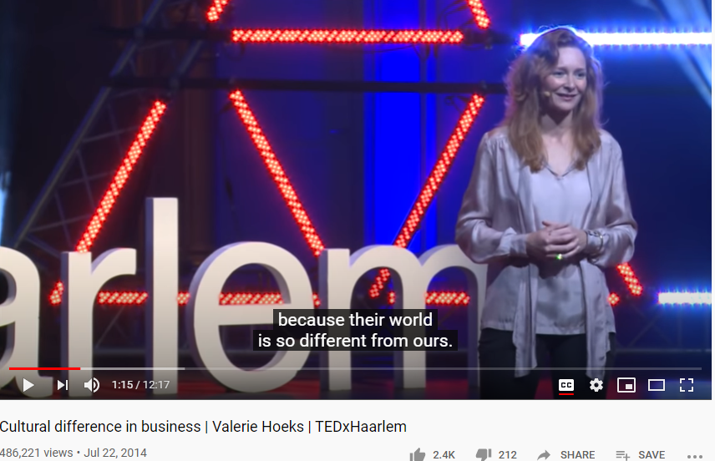

|  |  |
| --- | --- |
|  | PRAKTIK |

Please read the article and watch the video once again and discuss with your friends on the different business customs around the world compared to Indonesia. Fill in the column below and study the example.

|  |  |  |
| --- | --- | --- |
| **Country** | **Unique Customs** | **Indonesia** |
| **Finland** | *Hold important business meeting in a sauna.* | *Hold important business meeting in an office.* |
| **India** |  |  |
|  |  |  |
|  |  |  |
|  |  |  |
|  |  |  |
|  |  |  |
|  |  |  |
|  |  |  |

|  |  |
| --- | --- |
|  | **LATIHAN** |

Choose one country and find articles discussing its unique business customs. Read and discuss with your friends to fill out the required information below. Study the example.

|  |  |  |
| --- | --- | --- |
| **No** | **Topic** | **Information** |
| *1.* | *Country* | *Brazil* |
| *2.* | *Brief Introduction* | *Brazil is the largest country in South America. It is very famous for the football team and the Amazon river along with the biggest forest in the world.* |
| *3.* | *Business prospect (IT)* | *Most of the global tech giants have offices in Brazil.*  *Brazil’s government embraces the Internet of Things (IoT) technology.*  *Facebook opened its first innovation center n the world in Brazil.* |
| *4.* | *Unique Business Customs (Do’s and Don’ts)* | *Schedule a meeting at least two weeks in advance.*  *Greet by handshake (all male) or kissing both cheeks (women involved)*  *Hold meetings in a café or restaurant.*  *Dress appropriately and be on time.* |
| *5.* | *Why we must go/work there?* | *Because it is a beautiful country with friendly people.*  *Famous for its tourism places.*  *Etc…* |

|  |  |
| --- | --- |
| **tugas.png** | **TUGAS** |

Please remake the information you have gathered from the column above into an infographic to be uploaded via padlet link: <https://padlet.com/kuliahnafisa/tpil7m6ev9xpa0ku>

Below is the content of the infographic:

* 1. Title
  2. Student’s ID: name, nim, class
  3. Introduction to the country
  4. Business prospect (IT)
  5. Unique business customs: the Dos (must do)
  6. Unique business customs: the Donts (don’t do)
  7. Why we must visit/go/work there
  8. Sources: references links

|  |  |
| --- | --- |
|  | **REFERENSI** |

1. **Video link for business customs around the world:** [**https://www.youtube.com/watch?v=7T-Wf3Wdbms**](https://www.youtube.com/watch?v=7T-Wf3Wdbms)

**Vide on business culture in China:** [**https://www.youtube.com/watch?v=pPu2ZKakLuI**](https://www.youtube.com/watch?v=pPu2ZKakLuI)

1. **Video link for good and bad infographics:**

**Types of infographic:** [**https://www.youtube.com/watch?v=A6_7zC0mB9w**](https://www.youtube.com/watch?v=A6_7zC0mB9w)

**Bad infographic :** [**https://www.youtube.com/watch?v=o9bBLAHhFhg**](https://www.youtube.com/watch?v=o9bBLAHhFhg)

1. **Video link for creating infographic with canva:** [**https://www.youtube.com/watch?v=UFhKRS0gHrY**](https://www.youtube.com/watch?v=UFhKRS0gHrY)
2. **Image link for business custom around the world infographic:** [**https://farm6.staticflickr.com/5567/15188084541_b38d420b31_o.png**](https://farm6.staticflickr.com/5567/15188084541_b38d420b31_o.png)